April 13, 2026

To: Our Clients and Friends

From: Robert Bingham, CFA John Wright
Chief Investment Officer Senior Portfolio Manager
Senior Portfolio Manager

Jared Soper Tyler Waterman
Senior Portfolio Manager Director of Research
Portfolio Manager

Re: First Quarter 2026 Review and Commentary

******************************************************************************

"The war in the Middle East is creating the largest supply disruption in the history of the global oil market."
— International Energy Agency Oil Market Report (March 2026)

The first quarter of 2026 was defined by major geopolitical events that have introduced new layers of uncertainty through which the market must navigate.

On the morning of January 3rd, the United States military captured Nicolás Maduro and his wife in Caracas. The two were transported from Venezuela to New York City to face criminal prosecution, primarily for narco-terrorism. Maduro’s Vice President, Delcy Rodríguez, subsequently assumed the role of acting leader and the U.S. lifted sanctions, indicating a shift in diplomatic relations. The White House is now overseeing the slow process of stabilization and economic recovery in Venezuela. This recovery will likely be dependent on the reinvigoration of Venezuela’s oil sector, which at one point produced over three million barrels of oil per day.

The events in Venezuela were significantly overshadowed on February 28th, when U.S. and Israeli forces launched coordinated attacks against Iran, killing Iranian Supreme Leader Ayatollah Ali Khamenei. In response to the death of their leader, the Islamic Revolutionary Guard Corps (IRGC) effectively closed the Strait of Hormuz, causing oil prices to skyrocket through the end of March.

Located along Iran's southern border, the Strait of Hormuz is considered the world's most vital oil chokepoint as its waters facilitate the passage of 20.5 million barrels of crude oil per day, or roughly 20% of global consumption. In addition, around one third of the world’s fertilizer trade goes through the Strait. It is estimated that shipping traffic has declined by 95% since the war started.

The price of Brent crude oil rose from around $70 pre-war to well over $100 in the span of a month as shown in the chart on the next page. The oil price movement led to a sell-off in U.S. Treasury bonds as the 10-year yield (represented by the blue line) increased from around 4% to 4.4% over the same timeline, reflecting concerns that inflation levels, now impacted by higher energy costs, will accelerate.

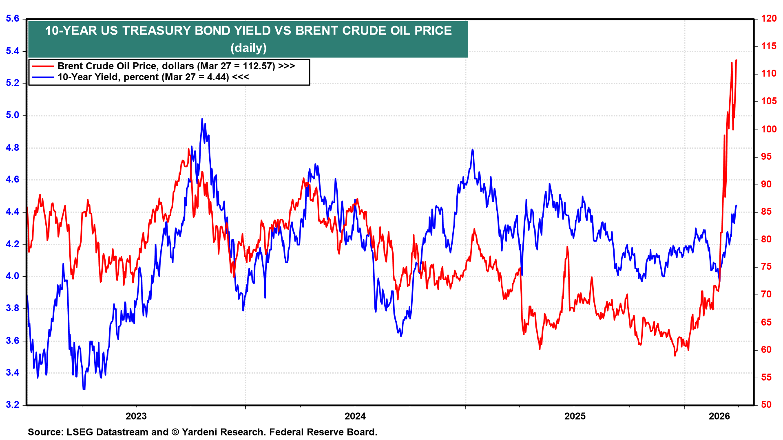
Strategist Ed Yardeni points out that higher oil prices, “shouldn’t heighten inflation as sharply in the U.S. as in Europe since the former is a net exporter of oil and gas while the latter relies on energy imports.” Therefore, while consumer spending may be dampened by higher costs in areas such as gasoline, air fare, and fertilizer, U.S. oil producers stand to benefit from higher prices.

The oil-supply shock that occurred as a result of the closing of the Strait of Hormuz has increased the probability of higher inflation from higher oil prices and thus has lowered the odds of rate cuts this year. The Federal Open Market Committee (FOMC) held the federal funds rate target range steady at 3.50%-3.75% following their March meeting. Market expectations for changes to the federal funds rate have aggressively shifted from two 25 basis-point rate cuts at the start of the year to no cuts at all per the chart below.

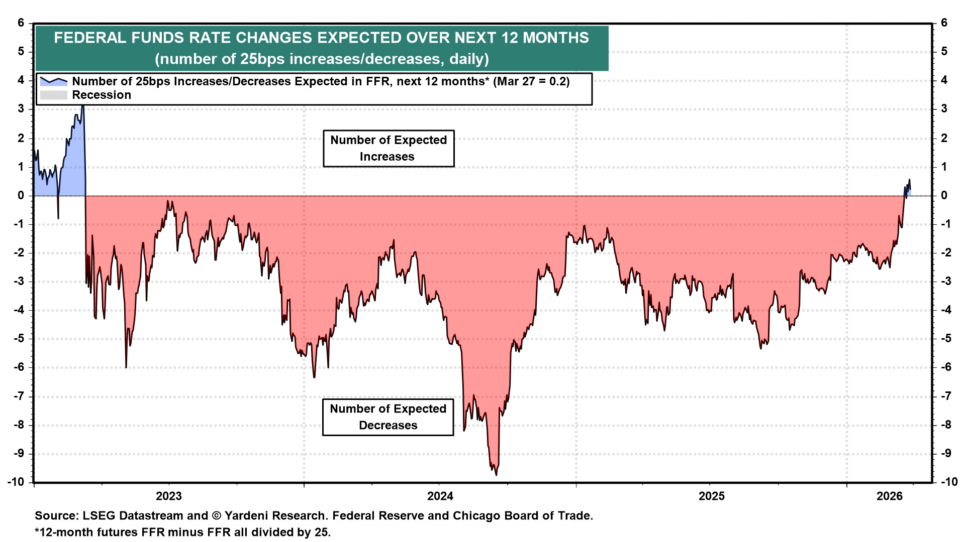
Federal Reserve Chairman Jerome Powell was asked at a press conference if there had been any discussion about the risk of stagflation, which is an economic environment characterized by low economic growth, high unemployment and high inflation. Mr. Powell responded that the term, “stagflation…was a 1970s term at a time when unemployment was in double figures, and inflation was really high…and that’s not the case right now. We actually have unemployment really close to longer run normal, and we have inflations that’s… 1 percentage point above that.”

In addition to volatility fueled by geopolitics, the market saw a rotation out of the Magnificent 7 and growth stocks and into value stocks as evidenced by the outperformance of the equal-weighted S&P 500 Index during the first quarter when compared to the market-cap weighted S&P 500 Index. The S&P 500 had a total return of -4.4% through March 31st while the equal-weighted S&P 500 was up 0.7%.

The Russell 2000 also eked out a slight gain of 0.9% while the Nasdaq declined 7%, both including dividends. Gold continued its hot streak from the prior year, finishing the quarter up over 8%, though well off its peak of over $5,500 per ounce in late January.

In the technology sector, software companies, like Microsoft and Salesforce, underperformed dramatically in the quarter due to fears that advancements in agentic artificial intelligence (AI) would cause disruptions and lead to fewer sales of licensed user accounts (aka seats). Investors are worried that AI tools will enable software users to be more efficient, thus requiring a smaller workforce to get the same amount of work done.

The AI startup Anthropic, which competes with OpenAI, was the cause of several headline-driven selloffs in software stocks due to the release of highly sophisticated tools in the enterprise software space. Claude Code, which facilitates programming tasks, and Claude Cowork, an agentic AI feature that acts as an autonomous assistant, are two flagship products from Anthropic that are expected to make workers more productive.

Stocks in industries such as legal, data services, financial analytics and cybersecurity were pressured after various announcements from Anthropic throughout the quarter. While it still may be too early to tell who the winners and losers will be among software-as-a-service (SAAS) providers, J.P. Morgan writes that we should consider whether AI is a threat to the product’s moat: “Deeply embedded, data-rich, mission-critical software is safer. Generic, labor-scaled, or easily replaced tools are at risk. Seat based revenue models are more at risk than usage based.”

While investors are hitting the sidelines and awaiting more clarity on the Iran war timeline, inflation expectations, AI disruption, and mid-term election results – analysts are expecting corporate earnings to grow around 14% in the first quarter, which is just about in-line with the prior quarter. Magnificent 7 companies are once again expected to outpace the rest of the S&P 500, with first quarter earnings growth consensus of around 24.2% versus 10.3% earnings growth for the other 493 companies that comprise the index.

Equity valuations have become more reasonable since the start of the year, with the S&P 500 price to earnings multiple contracting from over 22 in January to around 20 in early April, driven by the technology sector’s selloff.
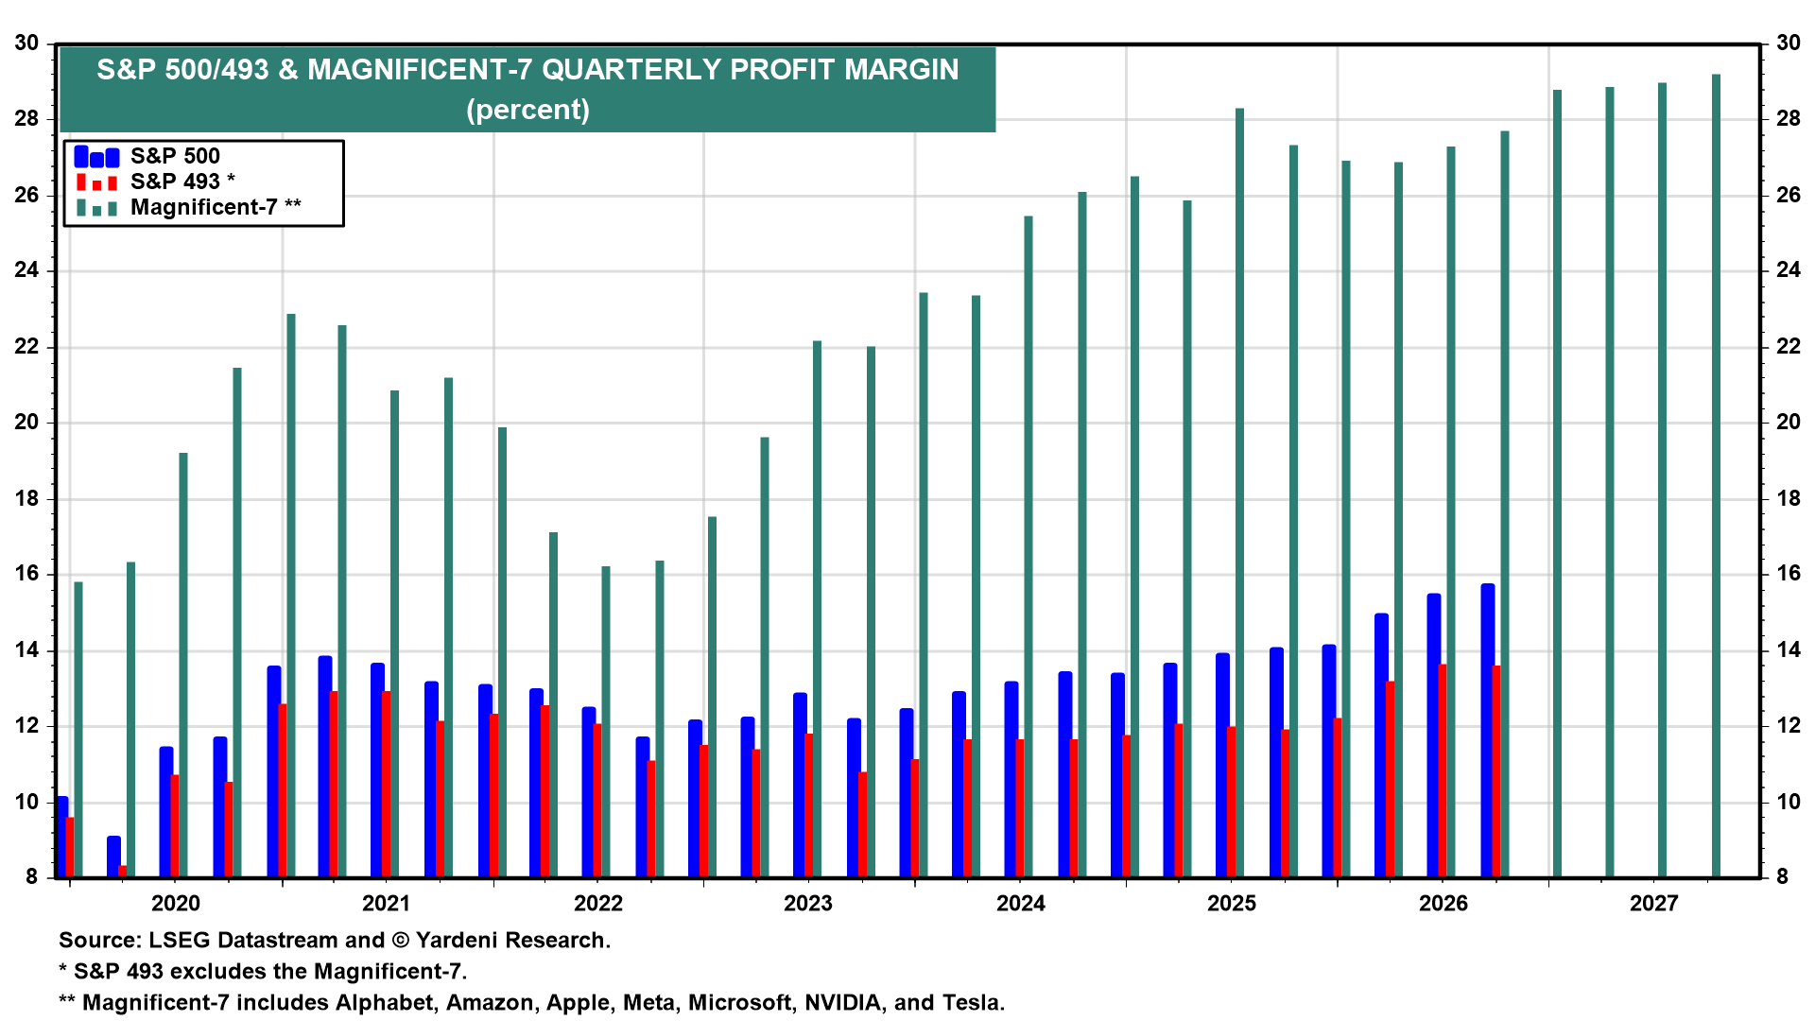

The current market correction combined with an outlook for continued margin expansion, highlighted in the chart above, provides an opportunity to slowly and strategically add to growth stocks for those with a long-term time horizon. Oil prices are likely to remain elevated until the Strait of Hormuz is fully opened and oil infrastructure in the Middle East is repaired, but any positive developments will be well received as the market is forward-looking.

In periods of heightened geopolitical tension and rapid technological shifts, investors’ natural impulse is to react to headlines. However, our focus remains on the underlying fundamentals, such as earnings growth and margin expansion. While the path through the remainder of 2026 remains clouded by the conflict in the Middle East and the evolution of AI, we believe a disciplined approach that balances high-quality growth with defensive positioning is the most prudent way to navigate this volatility. As always, we are monitoring these developments closely and remain committed to your long-term financial objectives.

Please don't hesitate to reach out if you would like to schedule a meeting to review your accounts or discuss your goals for the coming months. In the meantime, we hope you all enjoy the warmer spring weather.

Securities noted above valued as of the market close on April 10, 2026:

Alphabet Inc. Class C (GOOG $315.72) Amazon.com Inc. (AMZN $238.38) Apple Inc. (AAPL $260.48)
Meta Platforms Inc. (META $629.86) Microsoft Corp. (MSFT $370.87) NVIDIA Corporation (NVDA $188.63) Salesforce, Inc. (CRM $164.96) Tesla Inc. (TSLA $348.95)

These summary/prices/quotes/statistics contained herein have been obtained from sources believed to be reliable but are not necessarily complete and cannot be guaranteed. Errors and omissions excepted.

SKY Investment Group LLC
One Financial Plaza, Suite 1210, Hartford, CT 06103
(860) 761-9700 www.skyig.com

